**NASA Mars Data Analysis**

**Data Scraping**

The NASA Mars web scraping allowed me to extract and collect dynamic web pages with latest Mars news, changing Mars space featured images, latest Mars weather information, and the planet facts. In addition, I scraped and collected full resolutions images of Hemispheres from the USGS astrogeology site.

I used open source tools such as Beautiful Soup to parse html in the web pages, Splinter to navigate the sites, and Mongo DB to store the scraped data from a list of Python dictionaries. Finally, I used Mongo and an html template file to generate a single html page with all the collected data with images, facts, and news information.

**Conclusions**

* The current weather on Mars is colder than where we are. Both the high and low temperatures are below freezing.

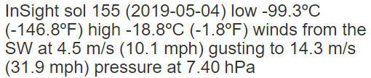

* The mass of Mars is only 10.7% of Earth and the surface temperatures are also below freezing. The equatorial and polar diameters are smaller than earth.

